//put time_slot value according to following

// 1. 3 am to 6 am – Light traffic

// 2. 6 am to 9 am – Medium Traffic

// 3. 9 am to 9 pm – Heavy Traffic

// 4. 9 pm to 3 am – Medium Traffic

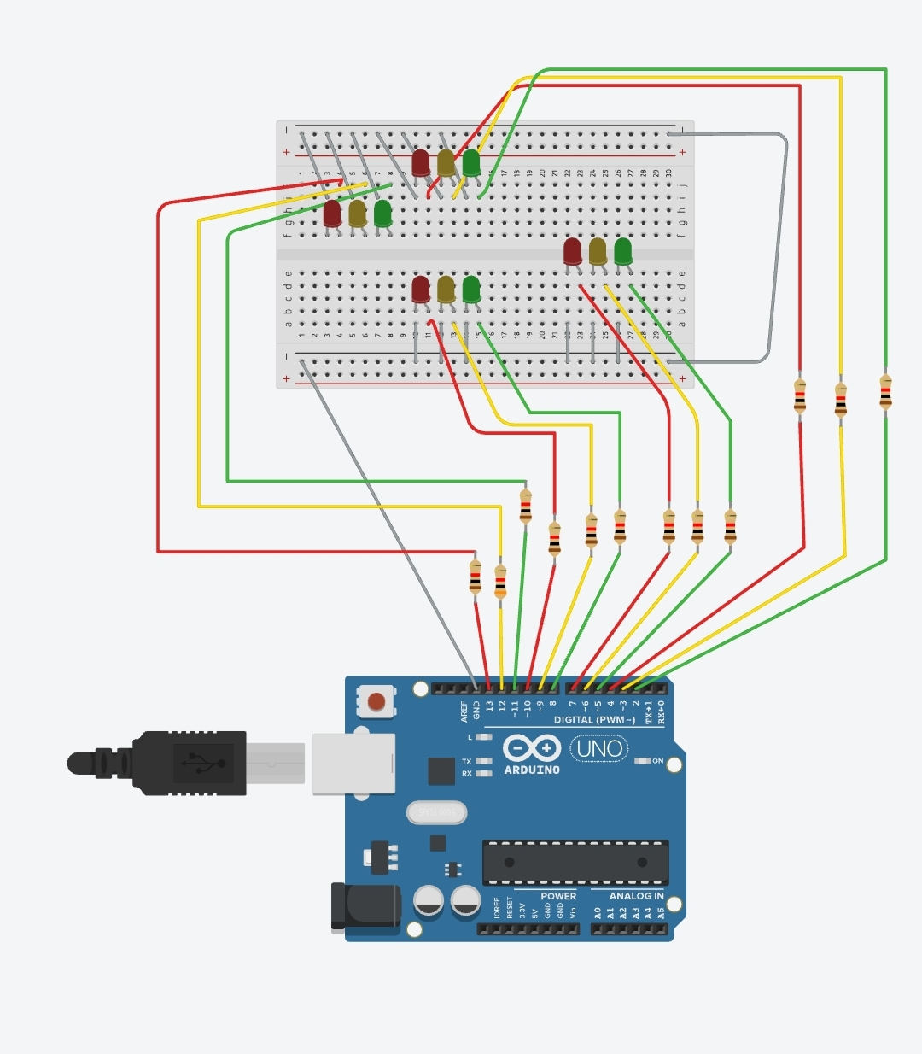

int time_slot=2;

void setup()

{

pinMode(13, OUTPUT);

pinMode(12, OUTPUT);

pinMode(11, OUTPUT);

pinMode(10, OUTPUT);

pinMode(9 ,OUTPUT);

pinMode(8 ,OUTPUT);

pinMode(7 ,OUTPUT);

pinMode(6 ,OUTPUT);

pinMode(5 ,OUTPUT);

pinMode(4 ,OUTPUT);

pinMode(3 ,OUTPUT);

pinMode(2 ,OUTPUT);

}

void loop()

{

if(time_slot==1 || time_slot==4){

digitalWrite(3, HIGH);

digitalWrite(6,HIGH);

digitalWrite(9,HIGH);

digitalWrite(12,HIGH);

delay(1000);

digitalWrite(3,LOW);

digitalWrite(6,LOW);

digitalWrite(9,LOW);

digitalWrite(12,LOW);

delay(1000);

}

if(time_slot==2){

//signal 1

digitalWrite(2,HIGH);

digitalWrite (7,HIGH );

digitalWrite (10,HIGH );

digitalWrite (13,HIGH );

digitalWrite(12,LOW);

digitalWrite(4,LOW);

delay(3000);

digitalWrite (2,LOW);

digitalWrite (3,HIGH);

digitalWrite (7,HIGH );

digitalWrite (10,HIGH );

digitalWrite (13,HIGH);

delay(1000);

//signal 2

digitalWrite(3,LOW);

digitalWrite(7,LOW);

digitalWrite (5,HIGH);

digitalWrite (4,HIGH );

digitalWrite (10,HIGH );

digitalWrite (13,HIGH );

delay (3000);

digitalWrite (5,LOW);

digitalWrite (6,HIGH);

digitalWrite (4,HIGH);

digitalWrite (10,HIGH);

digitalWrite (13,HIGH);

delay (1000);

//signal 3

digitalWrite(6,LOW);

digitalWrite(10,LOW);

digitalWrite (8,HIGH );

digitalWrite (4,HIGH);

digitalWrite (7,HIGH );

digitalWrite (13,HIGH);

delay (3000);

digitalWrite (8,LOW);

digitalWrite (9,HIGH);

digitalWrite (4,HIGH);

digitalWrite (7,HIGH );

digitalWrite (13,HIGH);

delay(1000);

//signal 4

digitalWrite(9,LOW);

digitalWrite(13,LOW);

digitalWrite (11,HIGH );

digitalWrite (4,HIGH);

digitalWrite (7,HIGH );

digitalWrite (10,HIGH);

delay (3000);

digitalWrite (11,LOW);

digitalWrite (12,HIGH);

digitalWrite (4,HIGH);

digitalWrite (7,HIGH );

digitalWrite (10,HIGH);

delay(1000);

}

if(time_slot==3){

//signal 2 and 4

digitalWrite (3,LOW);

digitalWrite (9,LOW);

digitalWrite (7,LOW) ;

digitalWrite (13,LOW);

digitalWrite (5,HIGH);

digitalWrite (11,HIGH);

digitalWrite (4,HIGH);

digitalWrite (10,HIGH);

delay(3000);

digitalWrite (5,LOW);

digitalWrite (11,LOW) ;

digitalWrite (6,HIGH);

digitalWrite (12,HIGH);

digitalWrite (4,HIGH) ;

digitalWrite (10,HIGH);

delay(1000) ;

//signal 1 and 3

digitalWrite(6,LOW);

digitalWrite(12,LOW);

digitalWrite (4,LOW);

digitalWrite (10,LOW);

digitalWrite (2,HIGH) ;

digitalWrite (8,HIGH) ;

digitalWrite (7,HIGH);

digitalWrite (13,HIGH);

delay(3000);

digitalWrite (2,LOW);

digitalWrite (8,LOW) ;

digitalWrite (3,HIGH);

digitalWrite (9,HIGH);

digitalWrite (7,HIGH) ;

digitalWrite (13,HIGH);

delay(1000) ;

}

}